Attendance Management System is an innovative tool to maintain and manage the attendance of students/employees. These tools can be a software to monitor attendance details.

Prefixing a word “online” to this tool makes this tool very resourceful technique. This is because now this tool can be accessed from anywhere around the globe.

So an online Attendance Management System is an innovative way to monitor and track the attendance of students/employee.  
Also this provides a transparency in the system so that each student can view their attendance from anywhere, anytime.

**Features of the project**

As soon as a teacher or a student joins the institution, he/she is requested to sign up to the online attendance management system. After this, admin is required to review and approve their account activation.  
As their account gets approved, they can access to their account.

**Users of System**

1. Teacher
2. Student

**Teacher**

* He/she is required to create account and then gets approved by the admin.
* Teacher can Choose/assigned multiple lectures.
* Teacher can manage multiple lectures multiple students Attendance.
* View the list of students assigned to them.
* Mark attendance after each lecture
* View attendance of each student assigned to them.
* Generate/Download Report of attendance in PDF Format
* Check Average Attendance
* Update Profile
* Upload Profile Pic
* Update Password(encrypted format)

**Student**

* He/she needs to create an account.
* Students can register himself/herself for multiple lectures.
* Students can Check Attendance for Multiple lectures.
* Can view their attendance from anywhere around the globe.
* Generate/Download Report of attendance in PDF Format
* Check Average Attendance
* Update Profile
* Upload Profile Pic
* Update Password(encrypted format)

**Brief overview of the technology:**

Front end: HTML, CSS, JavaScript

1. HTML: HTML is used to create and save web document. E.g. Notepad/Notepad++/Sublime Text3
2. CSS : (Cascading Style Sheets) Create attractive Layout
3. JavaScript: it is a programming language, commonly use with web browsers.
4. Bootstrap: for responsive and mobile friendly design.
5. JQuery.
6. Ajax.

**Front end: Android Client**

1. Java ,XML

Back end: PHP, MySQL

1. PHP: Hypertext Preprocessor (PHP) is a technology that allows software developers to create dynamically generated web pages, in HTML, XML, or other document types, as per client request. PHP is open source software.
2. MySQL: MySQL is a database, widely used for accessing querying, updating, and managing data in databases.

**Software Requirement (any one)**

* WAMP Server
* XAMPP Server
* MAMP Server
* LAMP Server

**Software Requirement (For Android App)**

* Android Studio
* Android Emulator /Physical Debug bridge enable device
* Local or Remote Server as backend

**Installation Steps(Local Configuration)**

1. Download zip file and Unzip file on your local server.  
2. Put this file inside " C:\xampp\htdocs".  
3. Database Configuration  
Open phpmyadmin  
Create Database named **attendance**  
Import database **attendance**.sql from project folder (inside database)  
4. Open your browser put inside "[http://localhost/project folder/](http://localhost/Online_exam_New/)"

**Installation Steps (Remote Configuration)**

1. Create A LAMP STACK on Google Cloud Compute Engine

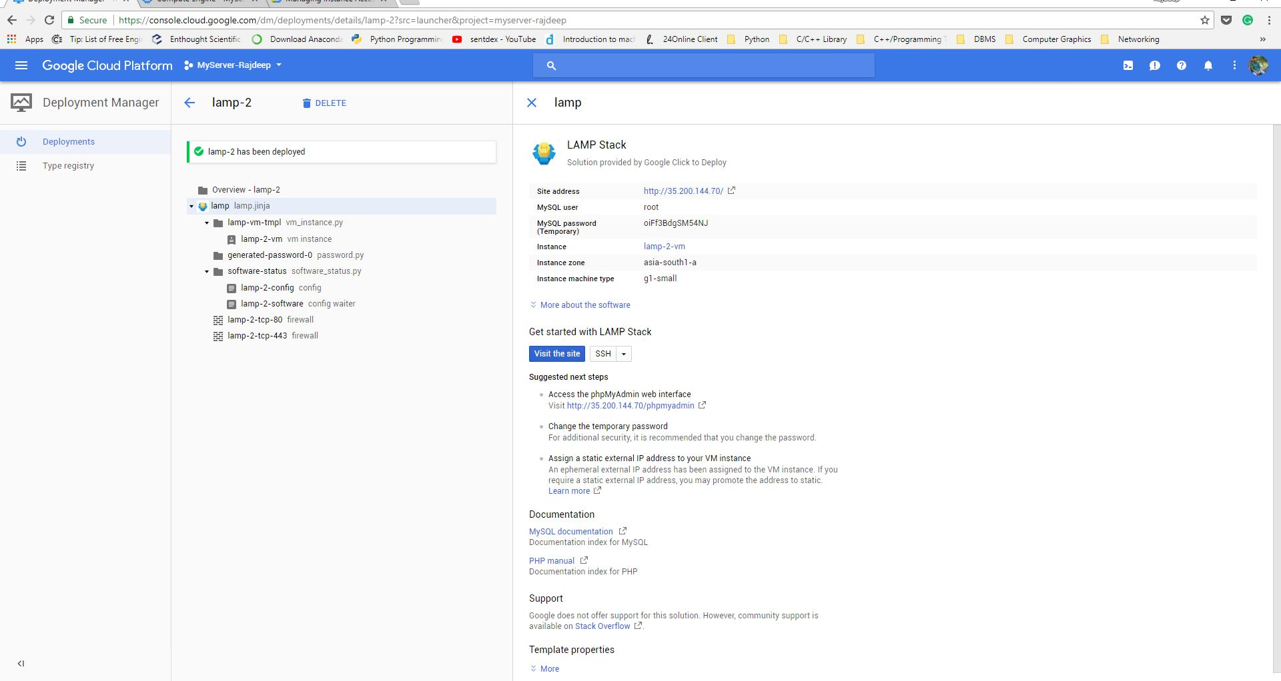2.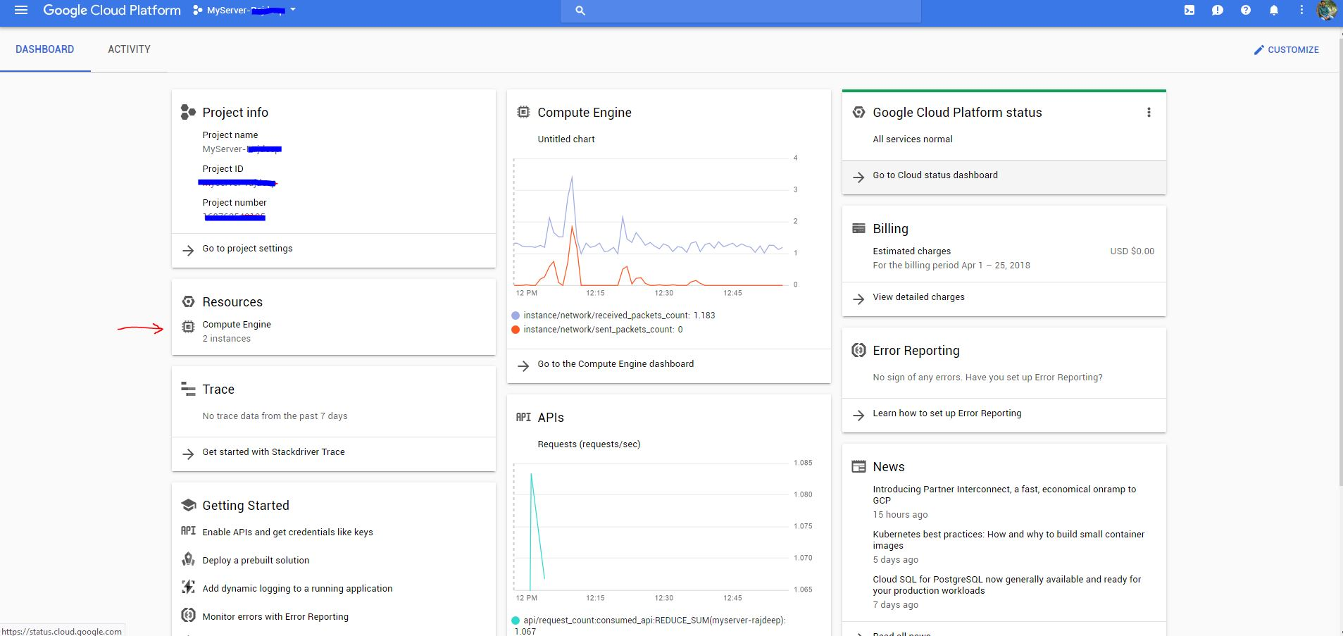 Log into GCP Console and Click on Compute Engine Resource

3. Obtain SSH Access, Public IP, Configure LAMP Stack (Running Debian 9, Apache2, Php7, and MySQL)

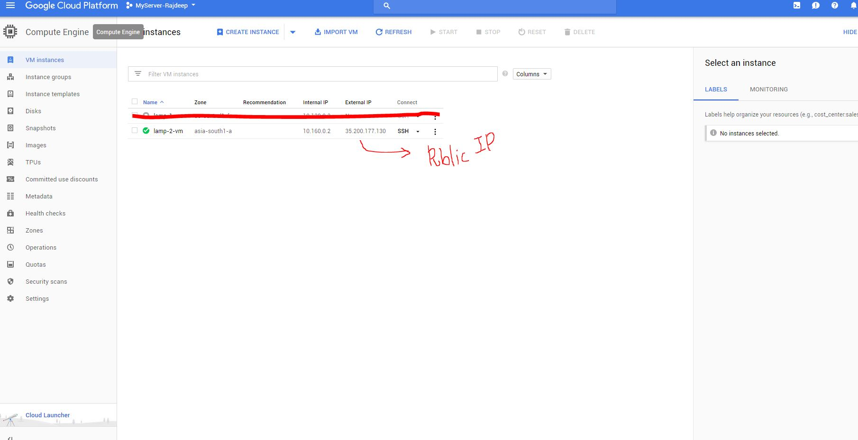4. Generate SSH Key and add it to the project metadata SSH access and configure SFTP 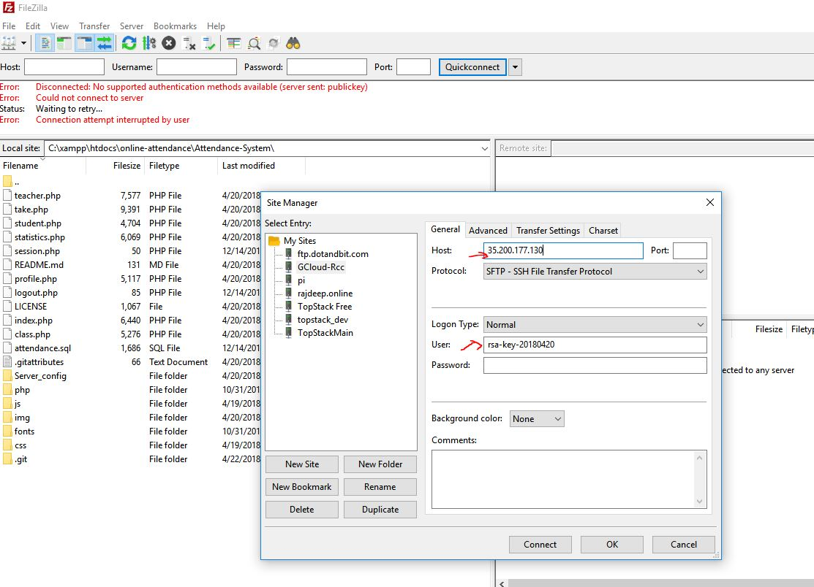(i)

4. Generate SSH Key and add it to the project metadata SSH access and configure SFTP (ii)

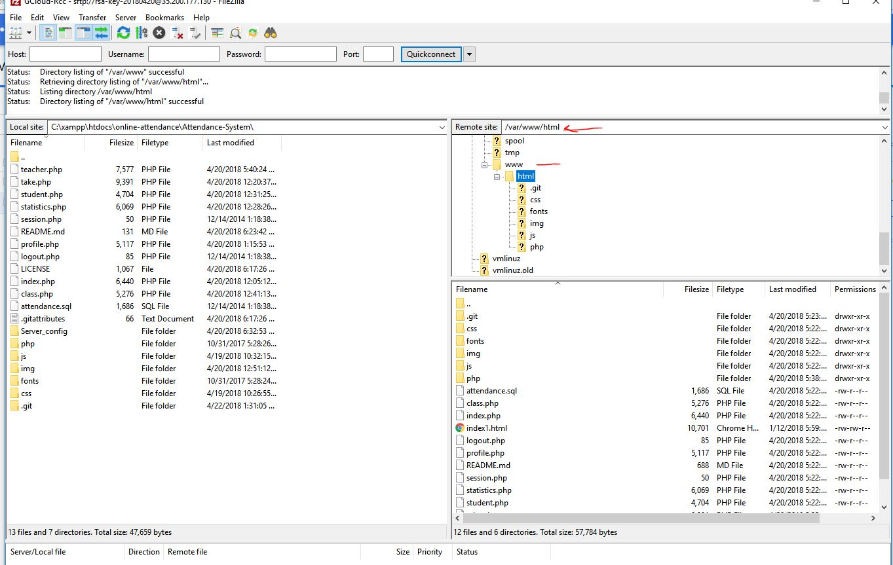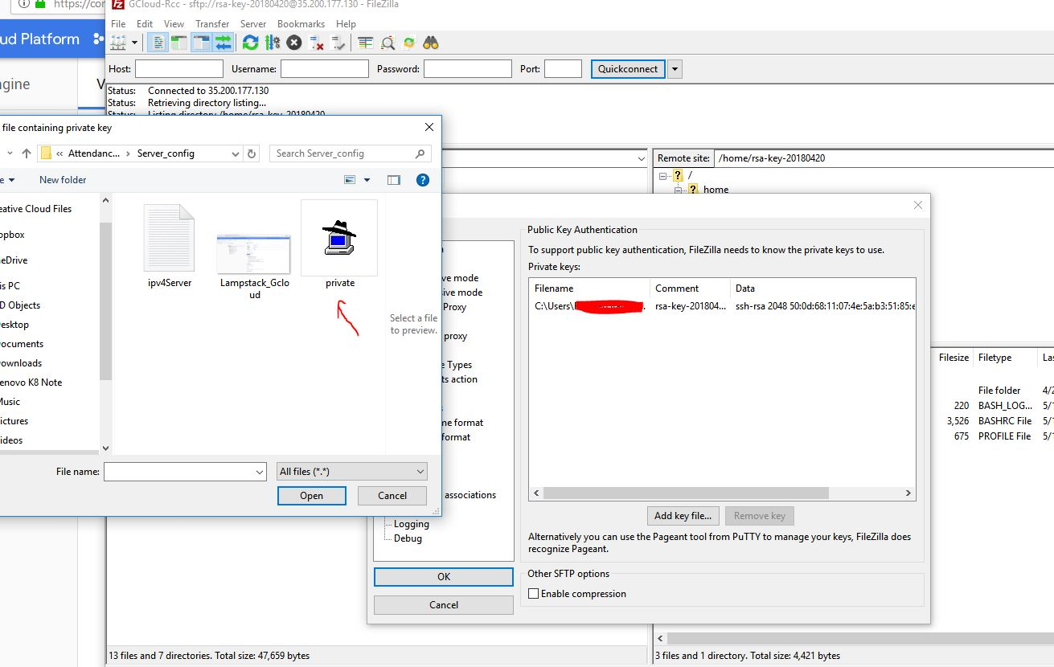5. Connect to The Server and Transfer the local files to **var/www/html** directory in remote Debian server.

5. Go to Remote Open phpmyadmin  
 Create Database named **attendance**  
 Import database **attendance**.sql from project folder (inside database)

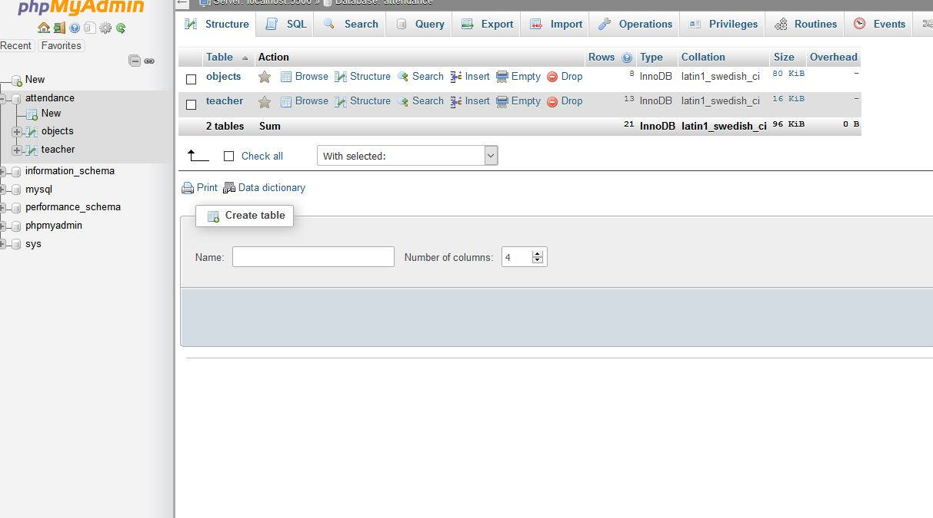6. Test Run/Demo

